A000-**Indo-Sulawesi, Toraja Grave Guardian-Wood-early 19th c**

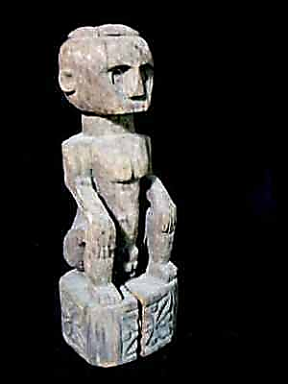 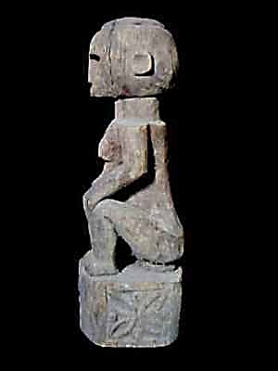 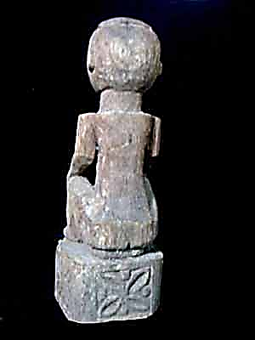 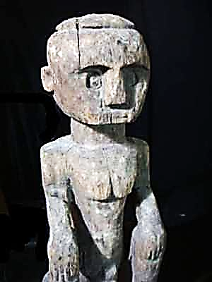

**Figs. 1-4. Indonesia, Sulawesi, Toraja Grave Guardian-Wood-early 19th c**

**Case no.:**

**Accession Number:**

**Formal Label:**

**Display Description:**

**LC Classification:**

**Date or Time Horizon:**

**Geographical Area:**

**Map:**

**GPS coordinates:**

**Cultural Affiliation:**

**Media:**

**Dimensions:**

**Weight:**

**Condition:**

**Provenance:**

**Discussion:**

**References:**

**Formal Label: Grave Guardian from the Toraja in South Sulawesi, Indonesia**

**Accession Number:** DS632.T7.A1

**Date or Time Horizon:** early 20th century

**Geographical Area:** South Sulawesi

**Cultural Affiliation:** Toraja

**Medium:** wood, patina of the figure is brownish-gray

**Dimensions:** H 30 in / 72 cm

**Weight:**

**Provenance**: grave figure of Toraja, Sulawesi, Indonesia